Practical No 02

Title - Perform data preprocessing tasks and Demonstrate performing association rule mining on data sets

Dataset –

@relation employee

@attribute empid numeric

@attribute name{raj,karan,vrunda,shubham, vishal,ram,sham,krushna}

@attribute salary numeric

@attribute gender {male, female}

@attribute contactno numeric

@attribute Yr_of_exp numeric

@attribute Designation {Trainer,Devloper,Tester,Team_Lead,Fresher}

@attribute email{raj123@gmail.com,karan32@gmail.com,vrunda123@gmail.com,shubham123@gmail.com,vishal23@gmail.com,ram123@gmail.com,sham123@gmail.com,krushna123@gmail.com}

@data

101, raj, 10000, male, 94568654,2,Trainer,raj123@gmail.com

102, karan, 10000, male, 80256895,4,Devloper,karan32@gmail.com

103, vrunda, 12000, female, 90258965,7,Team_Lead,vrunda123@gmail.com

104, shubham, 13000, male, 45895645,3,Tester,shubham123@gmail.com

105, raj, 12000, male, 96231485,2,Trainer,raj123@gmail.com

102, karan, 10000, male, 80256895,4,Devloper,karan32@gmail.com

106, vishal, 10000, male, 89562341,7,Team_Lead,vishal23@gmail.com

101, raj, 10000, male, 94568654,2,Trainer,raj123@gmail.com

102, karan, 10000, male, 80256895,4,Devloper,karan32@gmail.com

103, vrunda, 12000, female, 90258965,7,Team_Lead,vrunda123@gmail.com

104, shubham, 13000, male, 45895645,3,Tester,shubham123@gmail.com

105, raj, 12000, male, 96231485,2,Trainer,raj123@gmail.com

102, karan, 10000,male, 80256895,4,Devloper,karan32@gmail.com

106, vishal, 10000, male, 89562341,7,Team_Lead,vishal23@gmail.com

104, shubham, 13000, male, 45895645,3,Tester,shubham123@gmail.com

102, karan, 10000, male, 80256895,4,Devloper,karan32@gmail.com

107, ram, 17000, male, 54784895,2,Trainer,ram123@gmail.com

108, sham, 16000, male, 88956895,2,Tester,sham123@gmail.com

109, krushna, 19000, male, 87256895,2,Devloper,krushna123@gmail.com

Write a Dataset In Notepad Save it with .arff extension and save it. Upload The Data Set on Weka in Explore Attribute



Upload from here

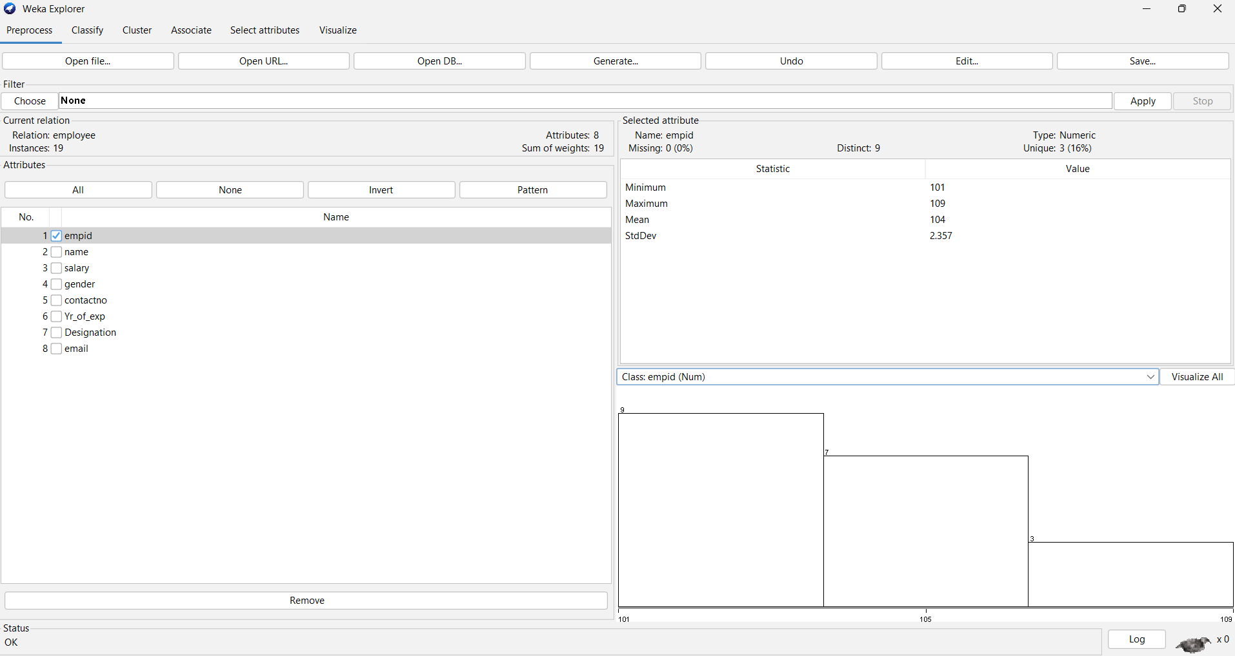

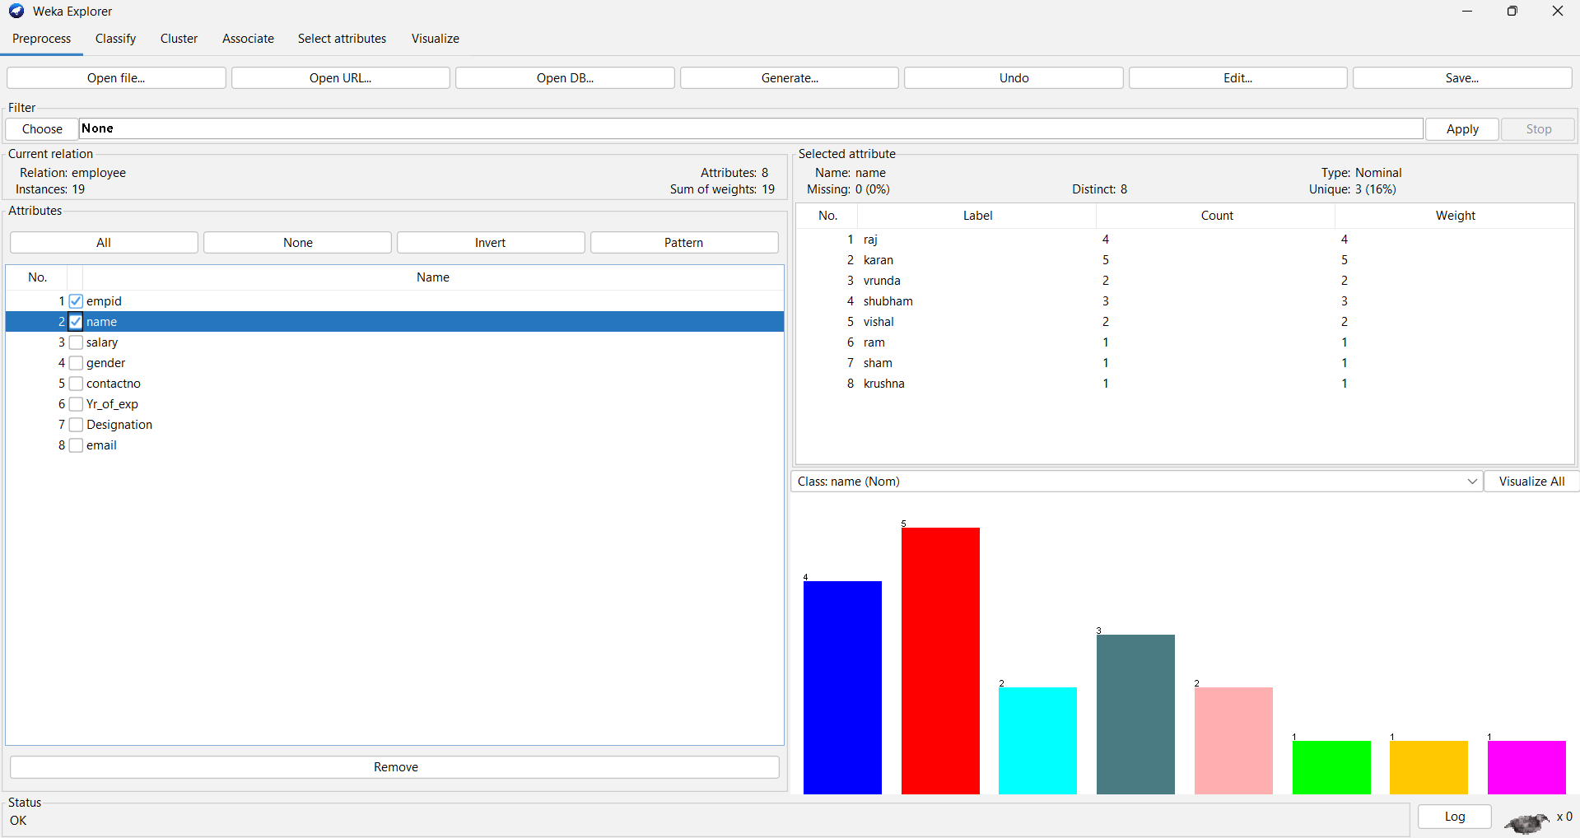

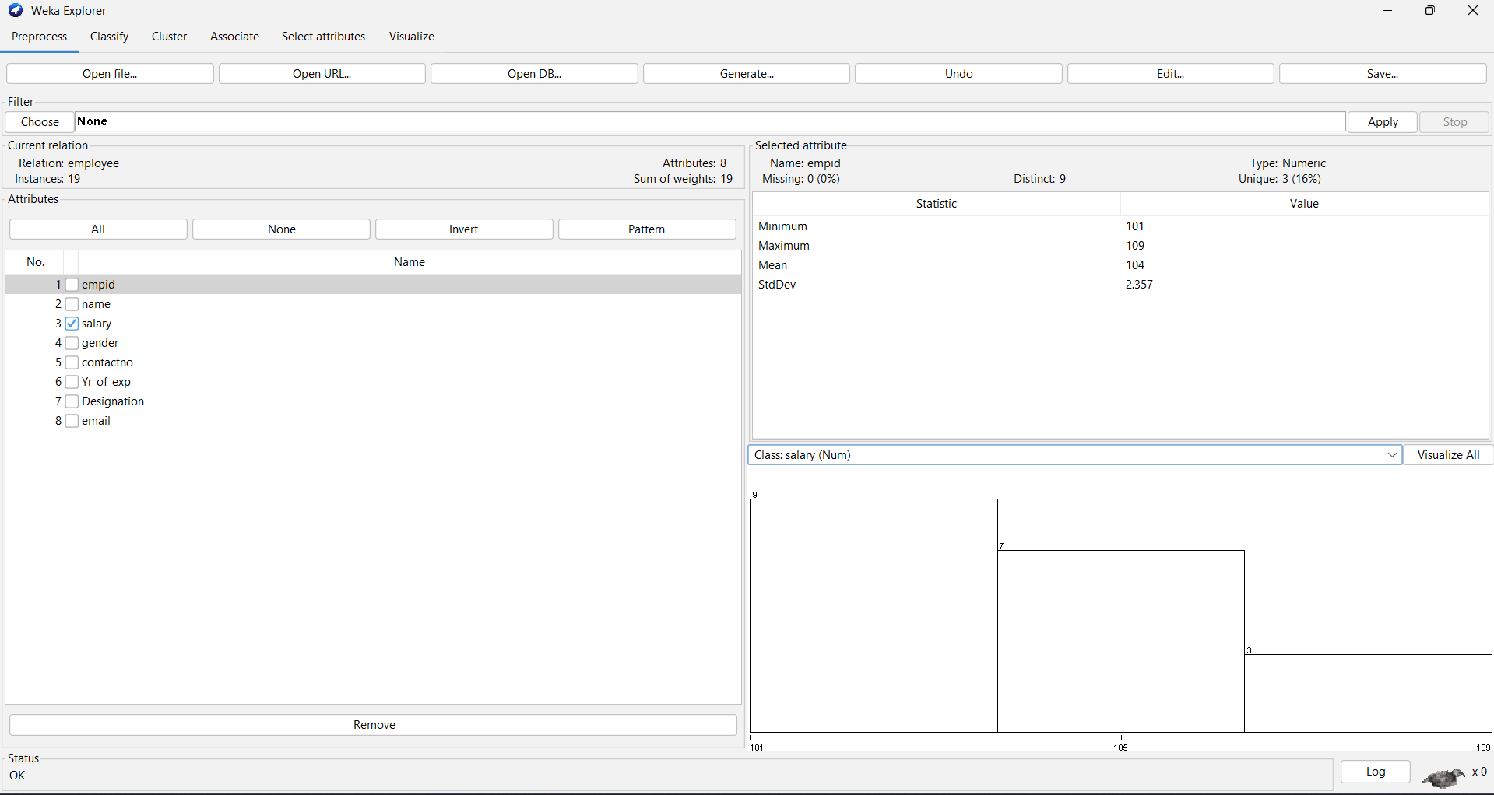

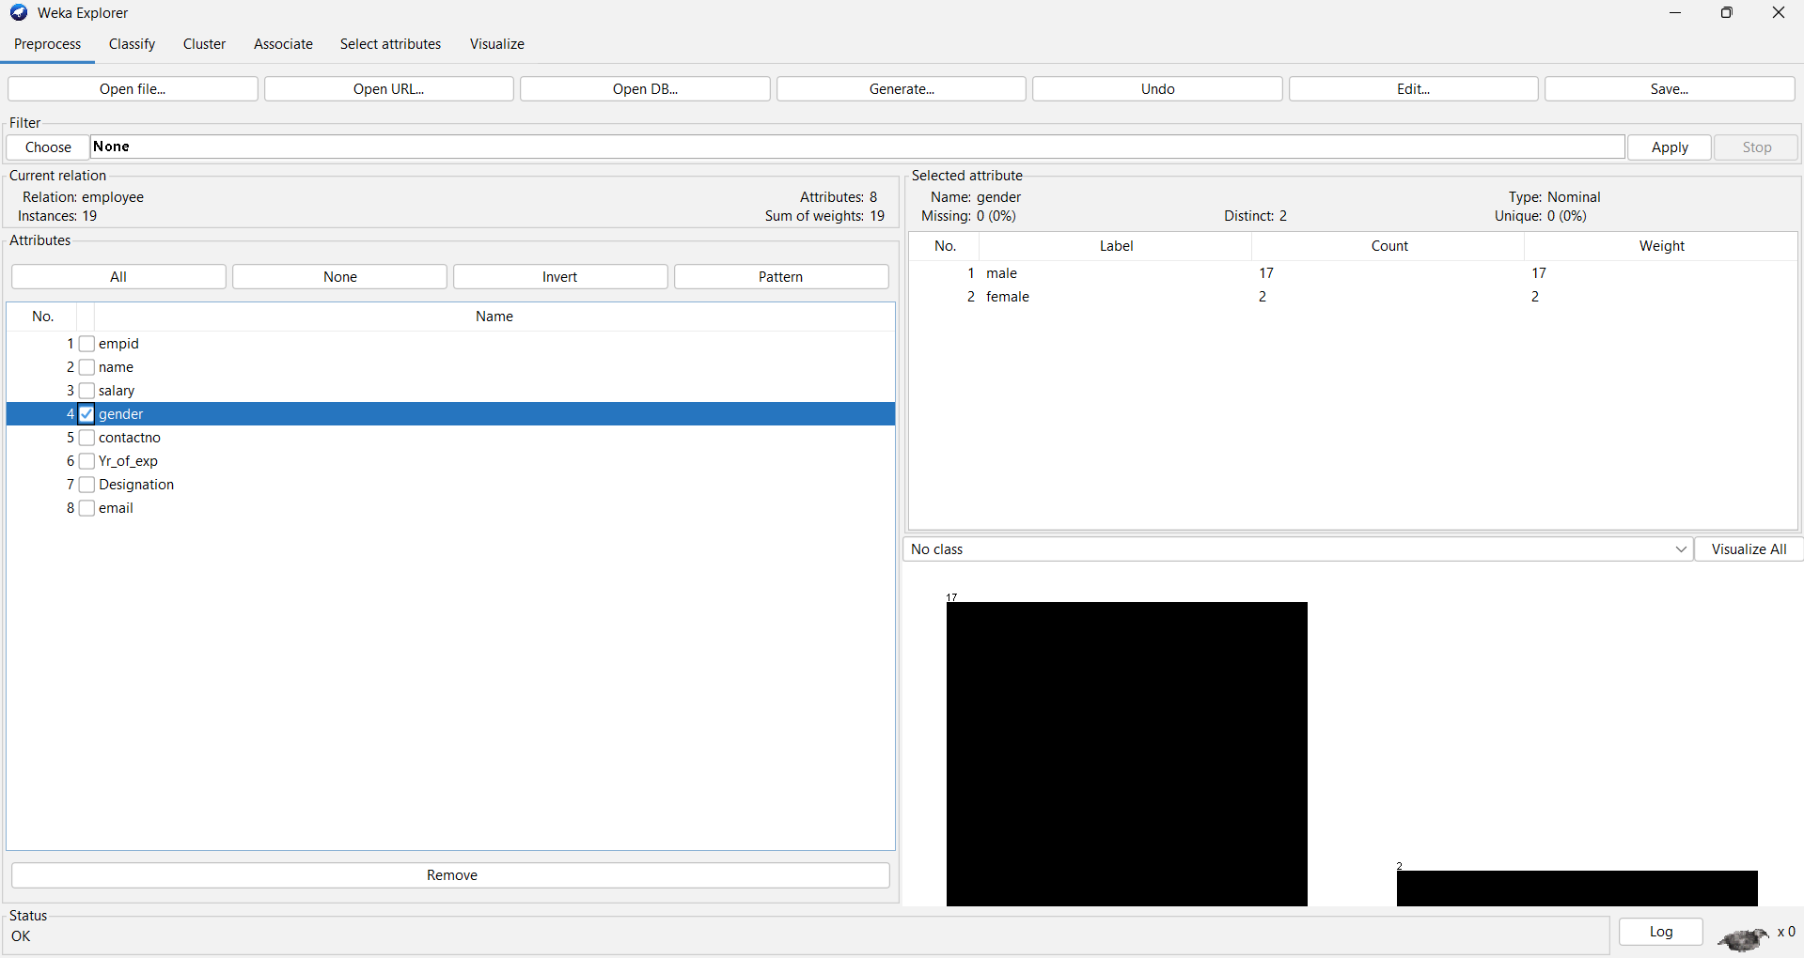

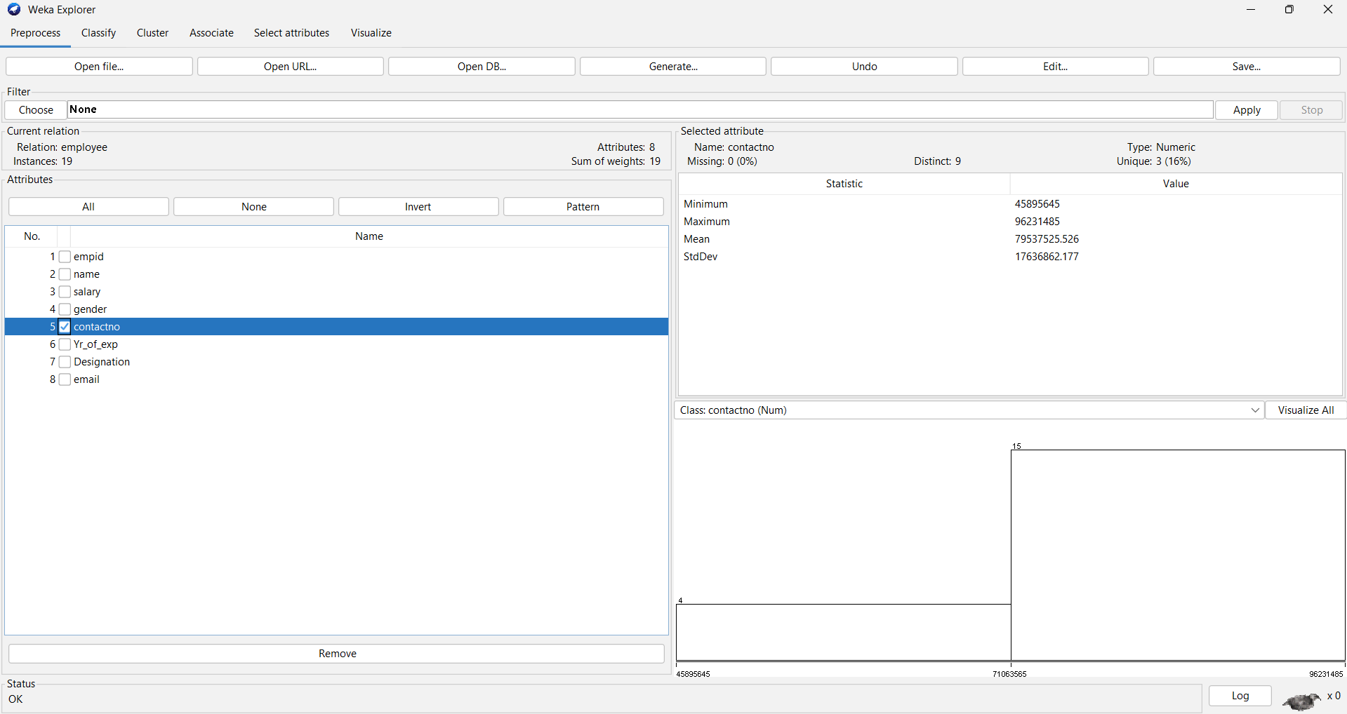

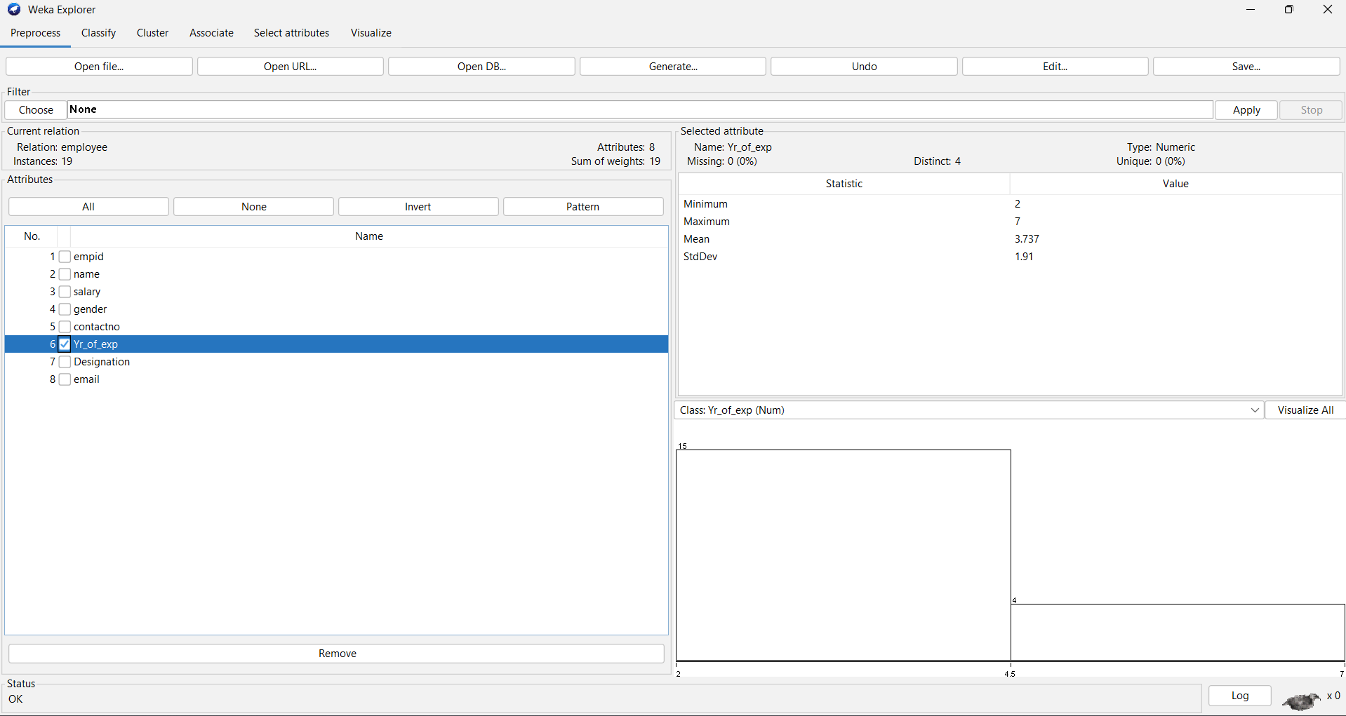

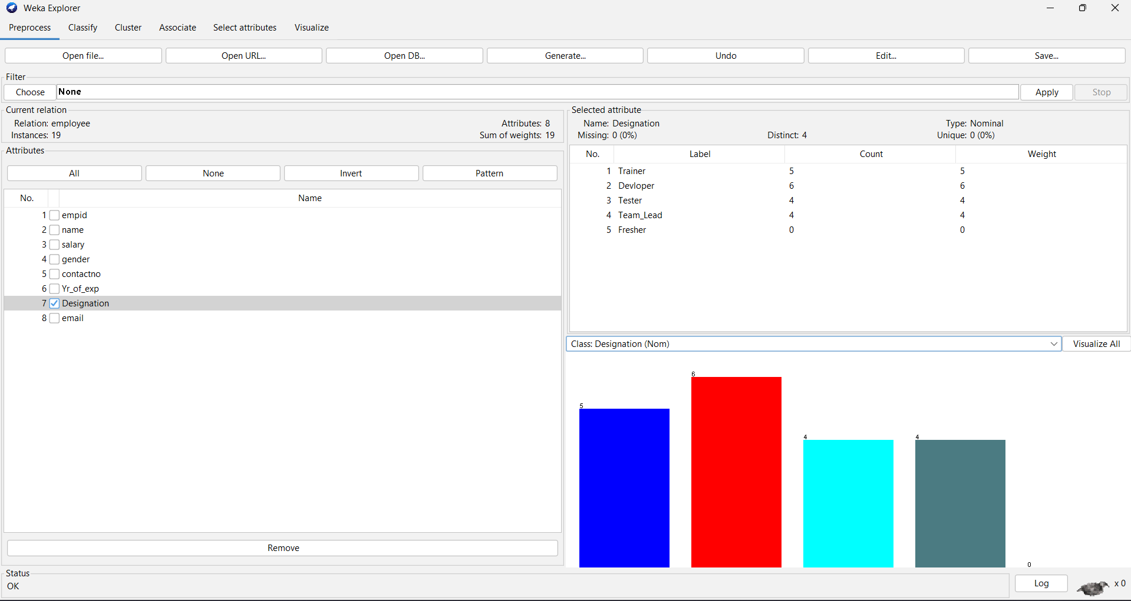

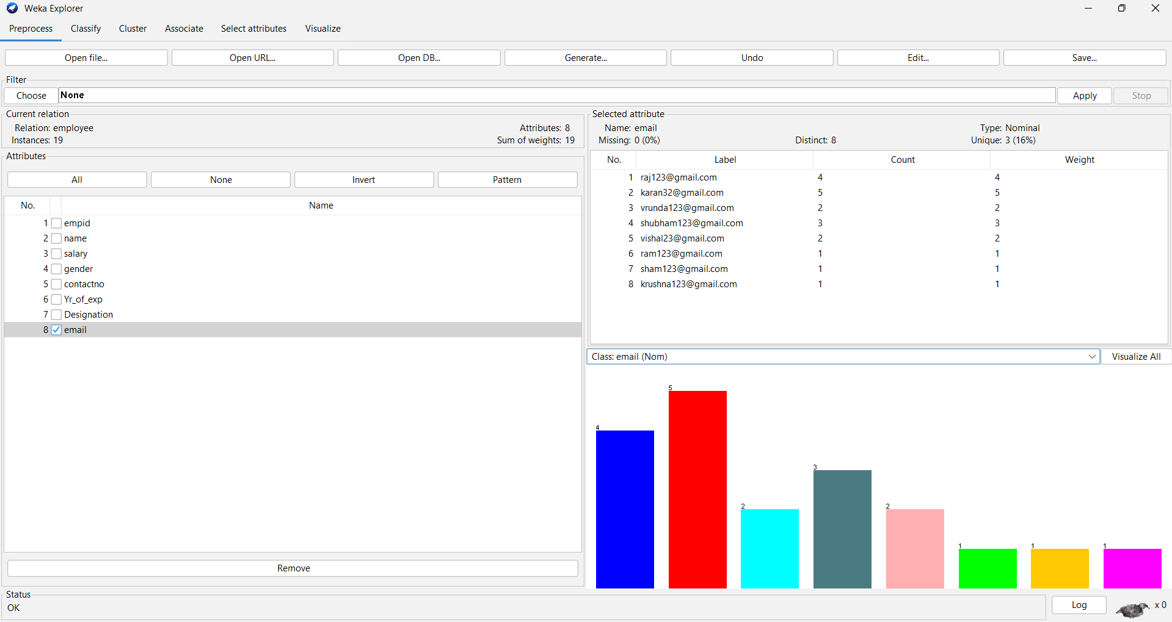

**Association Rule**

